Inhibition between Declarative and Procedural-Learning Categorization Systems

F. Gregory Ashby
Matthew J. Crossley

University of California, Santa Barbara

March 18, 2009

Contact: F. Gregory Ashby
Department of Psychology
University of California
Santa Barbara, CA 93106

Phone: 805-893-2130
Fax: 805-893-4303
Email: ashby@psych.ucsb.edu

Running head: System Interactions
ABSTRACT
Two experiments tested whether declarative and procedural memory systems operate independently or inhibit each other during perceptual categorization. Both experiments used a hybrid category-learning task in which perfect accuracy could be achieved via trial-by-trial switching between declarative and procedural strategies. In the two experiments, only 1 in 55 participants learned a strategy of this type. In Experiment 1, most participants used simple explicit rules, even though control participants reliably learned the procedural component of the hybrid task. In Experiment 2, participants pre-trained either with the declarative or procedural component and then transferred to the hybrid categories. Despite this extra training, no participants in either group learned to categorize the hybrid stimuli with a strategy of the optimal type. These results support the hypothesis that declarative and procedural memory systems inhibit each other during category learning. The most parsimonious account of these results is that only one system can be used at a time, and thus that there is complete inhibition.

During the past decade or so, overwhelming evidence has been reported that human categorization is mediated by a number of functionally distinct category-learning systems. The evidence suggests that these different systems are each best suited for learning different types of category structures, and are each mediated by different memory systems and by different neural circuits (e.g., Ashby, Alfonso-Reese, Turken, & Waldron, 1998; Ashby & O’Brien, 2005; Erickson & Kruschke, 1998; Love, Medin, & Gureckis, 2004; Nosofsky, Palmeri, & McKinley, 1994; Reber, Gitelman, Parrish, & Mesulam, 2003).
If human category learning is mediated by multiple systems, then an important question is to ask how the various systems interact and how their separate contributions are coordinated during the response selection process. Despite the obvious importance of these issues, we know of no behavioral evidence that directly addresses possible system interactions during category learning.
This article reports the results of two experiments that were designed to address the question of whether declarative and procedural category-learning systems operate independently during category learning, or whether one system inhibits or facilitates the other. Our results strongly favor inhibition. In fact, our results are consistent with a complete inhibition hypothesis – that is, that at any one time, only one of these systems can learn and control responding.
INTERACTIONS BETWEEN DECLARATIVE AND PROCEDURAL MEMORY SYSTEMS
When we say that two systems operate independently, we mean that each learns and performs just as effectively, regardless of whether the other system is also in operation, and that each system has unfettered access to the response. It is important to note, however, that even under these conditions, there will typically be some competition between the systems. If two separate systems are each suggesting a response, but the environment allows the participant to emit only one response, then the two systems will be in conflict any time they suggest competing responses. By unfettered access to the response, we therefore mean that the system capable of learning the categories is not prevented by the other system from expressing this knowledge.
An example of a model that assumes such independence is the COVIS model of category learning (Ashby, Alfonso-Reese, Turken, & Waldron, 1998). COVIS assumes separate rule-based and procedural-learning categorization systems that learn independently. The only competition in the model is for control of the observable response on each trial. In COVIS, this competition is resolved by allowing the more confident of the two systems to respond (much like the old Pandemonium model of Selfridge, 1959). Whichever system is better able to learn the categories will eventually come to dominate responding. If one of the two systems is lesioned or temporarily inactivated after learning is complete, then the independent learning will allow the other system to take over, although perhaps not at the same level of accuracy.
When we say that there is inhibition between the systems, we mean that when the systems are simultaneously active, neither is as effective as when it operates alone. There are at least two different ways that such inhibition could be manifest. One possibility is that one system inhibits learning in the other. A second possibility, however, is that the two systems learn independently, but the inhibited system is prevented from responding – that is, the inhibited system is denied the opportunity to express its knowledge.
We know of no behavioral data that address the question of how category learning systems interact. Some neuroimaging data are relevant, however. For example, a number of fMRI studies have reported an antagonistic relationship between neural activation in the basal ganglia and medial temporal lobes – that is, basal ganglia activation tended to increase with category learning, whereas medial temporal lobe activation decreased (Moody, Bookheimer, & Knowlton, 2004; Nomura et al., 2007; Poldrack, Prabhakaran, Seger, & Gabrieli, 1999; Poldrack et al., 2001). These results are consistent with the hypothesis that there is inhibition between declarative and procedural memory systems during category learning. Even so, several factors limit the strength of this conclusion.
First, in all of these studies the results are correlational. Although some methods for testing causality in fMRI data have been developed (e.g., Granger causality), these methods were not used in any of these studies. Second, in some cases, other brain structures not typically thought to be part of the declarative memory systems showed the same pattern of deactivation as the medial temporal lobes (e.g., posterior cingulate, superior temporal gyrus). Similarly, other studies did not perform relevant analyses of brain regions other than the medial temporal lobes and the basal ganglia (Nomura et al., 2007). Thus, in these cases the evidence is weak that the procedural memory system selectively inhibited declarative memory systems. Third, there are plausible alternative accounts of the negative correlations reported in these studies. For example, there is evidence that the hippocampus and other medial temporal lobe structures are part of the default mode network (Greicius & Menon, 2004; Greicius, Srivastava, Reiss, & Menon, 2004). If so, then the reported decrease in medial temporal lobe activation could be driven by the general decrease in the default network that is seen when participants engage in almost any cognitive task (Raichle et al., 2001). Finally, as already mentioned, none of these studies provide any behavioral evidence for inhibition between systems.
Similar results have been reported within the more general memory systems literature. For example, several fMRI studies of skill learning have also reported negative correlations between medial temporal lobe and striatal activation (Dagher, Owen, Boecker, & Brooks, 2001; Jenkins, Brooks, Nixon, Frackowiak, & Passinghem, 1994; Poldrack & Gabrieli, 2001). In addition, within this more general literature, there is behavioral evidence from animal lesion studies supporting an antagonistic relationship between medial temporal lobe and striatal memory systems. For example, a number of studies have reported that medial temporal lobe lesions can improve performance in striatal-dependent habit-learning tasks, or conversely that striatal lesions can improve performance in medial temporal lobe-dependent spatial learning tasks (e.g., Mitchell & Hall, 1988; O’Keefe & Nadel, 1978; Schroeder, Wingard, & Packard, 2002). Importantly, however, none of these behavioral studies used a category-learning paradigm.
In summary, although the available evidence hints at inhibition between declarative and procedural memory systems during human category learning, the neuroimaging evidence seems inconclusive, and there apparently is no behavioral evidence of such inhibition.
A HYBRID CATEGORY-LEARNING TASK
The category structures used in this article depend strongly on prior research with rule-based and information-integration category-learning tasks. In rule-based tasks, the categories can be learned via some explicit reasoning process. Frequently, the rule that maximizes accuracy (i.e., the optimal strategy) is easy to describe verbally (Ashby et al., 1998). In the most common applications, only one stimulus dimension is relevant, and the subject’s task is to discover this relevant dimension and then to map the different dimensional values to the relevant categories. A variety of evidence suggests that success in rule-based tasks depends on executive attention and working memory (Ashby et al., 1998; Maddox, Ashby, Ing, & Pickering, 2004; Waldron & Ashby, 2001; Zeithamova & Maddox, 2006), and is supported by a broad neural network that includes the prefrontal cortex, anterior cingulate, the head of the caudate nucleus, and medial temporal lobe structures (e.g., Brown & Marsden, 1988; Filoteo, Maddox, Ing, & Song, 2007; Muhammad, Wallis, & Miller, 2006; Seger & Cincotta, 2006).
In information–integration category-learning tasks, accuracy is maximized only if information from two or more stimulus components (or dimensions) is integrated at some pre-decisional stage (Ashby & Gott, 1988). In many cases the optimal strategy is difficult or impossible to describe verbally (Ashby et al., 1998). An example of an information-integration task is shown in Figure 1. In this case the two categories are each composed of circular sine-wave gratings that vary in the width and orientation of the dark and light bars. The diagonal line denotes the category boundary. Note that no simple verbal rule correctly separates the disks into the two categories. Nevertheless, many studies have shown that people reliably learn such categories, provided they receive consistent and immediate feedback after each response (for a review, see Ashby & Maddox, 2005). Evidence suggests that success in information-integration tasks depends on procedural learning (Ashby, Ell, & Waldron, 2003; Maddox, Bohil, & Ing, 2004; Spiering & Ashby, 2008) that is mediated largely within the striatum (Ashby & Ennis, 2006; Filoteo, Maddox, Salmon, & Song, 2005; Knowlton, Mangels, & Squire, 1996; Nomura et al., 2007).
INSERT FIGURE 1 ABOUT HERE
Rule-based and information-integration tasks have been invaluable, both for providing evidence that category learning is mediated by multiple systems, and for providing insights into the unique properties of two of these systems. In real life however, difficult category-learning problems are probably not dominated by a single system, as seems the case for both rule-based and information-integration category learning. Instead, it seems likely that multiple systems contribute. For example, radiologists clearly gain much explicit knowledge (e.g., from lectures in medical school) about assigning x-rays to the categories “tumor” versus “nontumor”. True expertise, however, also requires extended hands-on experience, and it seems plausible that procedural learning mediates some of the improvements that occur during this kind of training.
To study how explicit and procedural-learning systems interact, it seems preferable to use a task in which both systems are active. The problem with this approach however, is that in most such paradigms, it is impossible to tell which system is used on any given trial. The ideal task would be one in which both systems are heavily used but for which we could be reasonably confident as to which responses are controlled by the rule-learning system and which are controlled by the procedural-learning system. Such an ideal is probably not possible, but a task that attempts to achieve this goal is described in Figure 2. Each plus describes an exemplar from category A and each circle describes an exemplar from category B. As in Figure 1, the stimuli are circular sine-wave gratings. When bar width and orientation are both low, the optimal strategy requires information integration, whereas when orientation is high, a simple rule-based strategy can be used. This hybrid categorization task will be used in Experiments 1 and 2 to study how declarative and procedural systems interact during category learning.
INSERT FIGURE 2 ABOUT HERE
If declarative and procedural-learning systems operate independently, then the hybrid categories shown in Figure 2 should pose few challenges to participants. There are two prominent possibilities for how a model that assumes independence would perform with these categories. One possibility is that the rule-based system would categorize disks with steep orientations, and the procedural-learning system would categorize other disks. Thus, control would switch back-and-forth between the two systems on a trial-by-trial basis. Because many studies have shown that the one-dimensional strategy used by the rule-based system and the diagonal bound used by the procedural system are both straightforward for healthy young adults to learn (for a review, see e.g., Ashby & Maddox, 2005), this class of models predicts near optimal performance on the hybrid categories.
The other possibility, and the one predicted by COVIS, is that the procedural-learning system would come to dominate performance because the procedural system can learn the hybrid bound, or at least learn a bound that closely approximates the hybrid bound. For example, note that the hybrid bound can be accurately approximated by a quadratic curve, and many previous results have shown that people reliably learn quadratic category boundaries (e.g., Ashby & Maddox, 1992; Maddox & Ashby, 1993). Since each system in COVIS has unimpaired access to the response, the ability of the procedural system to learn the hybrid categories would allow it to eventually control responding. As a result, COVIS also predicts near optimal performance on the hybrid categories.
EXPERIMENT 1
In Experiment 1, one group of participants learned the hybrid categories shown in Figure 2, and another group learned information-integration categories like those shown in Figure 1. A huge literature shows that one-dimensional rules are far easier for healthy young adults to learn than the Figure 1 information-integration categories (e.g., Ashby & Maddox, 2005). Therefore, if the two systems operate independently and they switch control on a trial-by-trial basis, then the information-integration task should be more difficult than the Figure 2 hybrid categorization task because success with the information-integration categories requires a difficult strategy on all trials, whereas a simple rule can be used for many trials with the hybrid categories. If the systems operate independently, but the procedural system dominates because it can achieve near perfect accuracy, then there should be no qualitative difference in performance between the two tasks. Learning might be somewhat slower with the hybrid categories, but near optimal performance should be likely in both conditions. On the other hand, if there is inhibition between the two systems, then the hybrid task should be more difficult than the information-integration task because the frequent use of each system would slow learning in the other system.
Method
Participants
There were 24 participants in the Hybrid condition and 22 participants in the Information-Integration condition. All participants were UCSB undergraduates who received course credit for completing the experiment.
Stimuli
Stimuli were gray-scale circular sine-wave gratings that varied across trials only in spatial frequency (cycles per degree, CPD) and orientation (radians, rad). Each stimulus subtended approximately 5 degrees of visual angle and was displayed against a gray background using routines from Brainard’s (1997) Psychophysics toolbox.
To create stimuli for the Hybrid condition we first drew 300 random samples from the uniform distribution defined over the A region illustrated in Figure 2. We then drew another 300 random samples from the uniform distribution defined over the B region illustrated in Figure 2. The result of this process was 600 ordered pairs of numbers (x,y), with each value ranging between 0 and 100. These (x,y) pairs were then converted to stimuli with spatial frequency and orientation (f,o) via the following linear transformations:
f = x/30 + 0.25 (CPD)
o = (π/200)y (rad).
These linear transformations were selected in an attempt to equate the salience of spatial frequency and orientation dimensions.
To create stimuli for the Information-Integration condition we first drew 600 random samples from the uniform distribution defined over the entire 0 to 100 space. Each (x,y) pair was given a category label according to the following rules: if x < y, then the stimulus is in category A, otherwise the stimulus is in category B. The (x,y) pairs were then converted to stimuli with spatial frequency and orientation (f,o) via the same linear transformation used for the hybrid stimuli.
Procedure
The experiment took place in a dimly lit room over the course of two 60-minute sessions that occurred within 48 hours of each other. On day 1, participants were informed that they would be learning to classify novel stimuli into an A category or a B category according to a hidden, experimenter-defined structure. They were told that the stimuli would be circles with stripes that could only vary in stripe thickness and stripe angle. On day 2 they were told that they would be doing exactly the same experiment that they did on day 1.
Each trial of the experiment began with a fixation cross that was followed by stimulus onset 1 second later. The stimulus was cleared from the screen immediately after a response was made. Subjects received a visual and auditory warning if they failed to respond within 3 seconds of stimulus onset. Each trial was completed with auditory feedback indicating whether the response was correct or incorrect. Feedback following a correct response was a 0.73 second sine wave tone at 500 Hz and feedback following an incorrect response was a 1.22 second sine wave tone at 300 Hz. There was an intertrial interval of 2 seconds between feedback offset and the next stimulus onset, although the fixation cross was visible immediately after feedback termination. Participants used two keys on a standard keyboard labeled “A” and “B” to make their responses.
The same 600 stimuli were used on both days. The order of stimulus presentation was randomized across participants and across days so that every session used the same stimuli in a different order.
Results
Accuracy-Based Analyses
Figure 3 shows the average learning curves for both conditions across both days in Experiment 1. Average accuracy in the Hybrid condition is greater than average accuracy in the Information-Integration condition on every block of the experiment. This difference is significant by a sign test [12/12, p < 0.001]. Even so, a 2 × 12 mixed ANOVA [2 conditions (Hybrid versus Information-Integration) × 12 blocks] revealed no main effect of condition [F(1,44) = 1.29, p = 0.262] and no interaction [F(11,484) = 1.186, p = 0.294], although the main effect of block was significant [F(11,484) = 8.00, p < 0.001].
INSERT FIGURE 3 ABOUT HERE
Model-Based Analyses
The accuracy-based analyses suggest that performance in the Hybrid condition may have been slightly better than in the Information-Integration condition. Before drawing any strong conclusions from this result, however, it is important to know what decision strategies participants used in these two conditions. In particular, it is critical to know whether Hybrid participants eventually adopted a hybrid decision strategy. To answer this question, we fit four different types of decision bound models (e.g., Maddox & Ashby, 1993) to the data from each individual participant: hybrid, information-integration, rule-based, and pure-guessing models (see the Appendix for details). The hybrid models assumed participants used a hybrid strategy, but allowed for suboptimalities in the slope and intercept of the diagonal piece of this bound (i.e., see Figure 2) and in the x-intercept of the vertical component of the bound. The information-integration models assumed that the decision bound was a single line of arbitrary slope or intercept. The rule-based models assumed either a single vertical or horizontal bound, or that participants used a conjunction rule of the type: Respond A if the bar width is narrow and the orientation is steep; otherwise respond B. Finally, as their name implies, the pure-guessing models assumed participants guessed at random on each trial. All four types of models were fit separately to the data from the last 100 trials of days 1 and 2 of each individual participant.
Table 1 shows the number of participants in the two conditions whose data were best fit by a model of each of these four types. Note that in the Information-Integration condition, about 2/3 of the participants used an information-integration strategy on both days of the experiment. However, in the Hybrid condition, no participants used a hybrid strategy on the first day, and only one participant used a hybrid strategy on the second day. This difference is significant – that is, the percentage of participants using a strategy of the optimal type was significantly greater in the Information-Integration condition than in the Hybrid condition [binomial test; t(46) = 4.81, p < .001]. In the Hybrid condition, four participants used an information-integration strategy on each day, but more than 80% of the participants used a rule-based strategy. Most of these used a one-dimensional rule, with only four participants on day 1 and one participant on day 2 using a conjunction rule.
INSERT TABLE 1 ABOUT HERE
A comparison of Figures 1 and 2 suggests that a vertical line decision bound will achieve higher accuracy in the Hybrid condition than in the Information-Integration condition. This raises the possibility that the higher overall accuracy of participants in the Hybrid condition (see Figure 3) may be because one-dimensional rules are more successful in the Hybrid condition, rather than because Hybrid participants learned more. To answer this question, we separated out the participants in the Information-Integration condition who used a rule-based strategy. Figure 4 shows the learning curves following this partitioning of Information-Integration participants by strategy. Note that, as predicted, the accuracy difference in Figure 3 is driven by the poor performance of the Information-Integration participants who used a one-dimensional rule.
INSERT FIGURE 4 ABOUT HERE
Discussion
Perfect accuracy is possible with the hybrid categories if a simple one-dimensional rule is used on some trials and a more complex information-integration strategy is used on the other trials. Many previous studies have shown that healthy young adults learn one-dimensional rules far more quickly than strategies that require information-integration (e.g., Ashby & Maddox, 2005). Therefore, if rule-based and procedural learning occur independently and control is switched between the two systems on a trial-by-trial basis, then the hybrid categories should be easier to learn than the information-integration categories because the Hybrid condition includes a mixture of easy (i.e., rule-based) and difficult (i.e., information-integration) trials, whereas all trials in the Information-Integration condition required implementing a difficult strategy. In contrast to this prediction, we found no advantage in the Hybrid condition. There was a (nonsignificant) trend for higher Hybrid accuracy, but we saw that this difference was driven completely by the fact that one-dimensional rules achieve higher accuracy with the hybrid categories than with the information-integration categories. Surprisingly, only 1 of 24 Hybrid participants ever adopted a strategy of the optimal type. In contrast, 16 of 22 Information-Integration participants adopted an information-integration strategy. Thus, our participants were far more successful at learning the information-integration strategy required in the Information-Integration condition than at learning the hybrid strategy required in the Hybrid condition.
These results are also inconsistent with the COVIS prediction that participants learned the information-integration and hybrid categories using the same system. If this was true, then we would expect approximately equal success rates in the two conditions. Instead, although most participants used a strategy of the optimal type in the Information-Integration condition, only one participant in the Hybrid condition used a strategy of the optimal type. Note that our model-based analyses also rule out the possibility that participants consistently approximated the optimal piecewise linear bound with a smooth quadratic bound. If this were true, then a model assuming a hybrid-type bound would have fit better than model that assumed an explicit rule or models that assumed a single linear bound.
In summary, the results of Experiment 1 are inconsistent with the hypothesis that the two systems learned independently. Instead, they support an inhibition hypothesis. In fact, the dominant use of rules in the Hybrid condition suggests that use of explicit rules may inhibit either the learning or the use of procedural strategies.
EXPERIMENT 2
The results of Experiment 1 indicate that people failed to learn the hybrid categories. The results of the Experiment 1 Information-Integration condition indicated that about 1/3 of those participants failed to learn the information-integration categories, despite two days of training. One possible reason for the poor performance of the Hybrid participants, therefore, could be that they mostly failed on the information-integration component of the hybrid bound (i.e., the diagonal component). The results from the Information-Integration condition suggest that this component is difficult to learn even when every trial can be used for practice. With the hybrid categories, only some trials require information-integration, so an optimal Hybrid participant would have less overall practice at information-integration.
Experiment 2 tests this hypothesis by pre-training participants on either the information-integration component of the hybrid bound or on the rule-based component. The design is illustrated in Figure 5. If the Experiment 1 Hybrid participants performed poorly because they did not have enough practice at the more difficult information-integration component of the hybrid bound, then pre-training with this component should lead to much better performance on the hybrid categories than pre-training on the simpler rule-based component.
INSERT FIGURE 5 ABOUT HERE
In the Information-Integration Training condition of Experiment 2, participants trained for 600 trials on the information-integration component of the hybrid bound, and then transferred to the hybrid categories on the second day. In the Rule-Based Training condition, participants trained for 600 trials on the rule-based component of the hybrid bound, and then transferred to the hybrid categories on the second day. In the hybrid categories, the stimuli are uniformly distributed over each response region (i.e., see Figure 2). If we had used similar uniform distributions for the pre-training categories, then because one-dimensional rules are so easy for people to learn, the Rule-Based Training participants would have achieved much higher accuracy than the Information-Integration Training participants by the end of the pre-training session. To avoid this confound, we trained participants on categories that were defined by bivariate normal distributions – that is, the exemplars in each pre-training category were random samples from a bivariate normal distribution. Bivariate normal distributions were chosen because by changing the category means and variances, we could easily change the category separation, and therefore categorization difficulty. In fact, we set the category overlap during rule-based training higher than during information-integration training in an attempt to control difficulty. As we will see, these efforts were reasonably effective.
Method
Participants
There were 15 participants in the Rule-Based Training condition and 16 in the Information-Integration Training condition. All participants were UCSB undergraduates who received course credit for completing the experiment.
Stimuli
The rule-based and information-integration categories used for training were created using the randomization technique developed by Ashby and Gott (1988). Specifically, the A and B categories were defined as bivariate normal distributions using the parameters defined in Table 2. Stimuli were generated by drawing 300 random samples (x,y) from each category distribution. The (x,y) values obtained from this process were transformed so that the sample statistics equaled the population parameter values reported in Table 2. Next, to control for statistical outliers, all (x,y) pairs more than three standard deviations away from the mean (i.e., Mahalanobis distance > 3; e.g., Fukunaga, 1972) were discarded and new samples were drawn to replace them. Finally, (x,y) pairs were converted to (f,o) pairs using the linear transformations:
f = x/30 + 0.25 (CPD)
o = (π/200)y + π/9 (rad).
INSERT TABLE 2 ABOUT HERE
Hybrid stimuli used for transfer were created by adding π/9 radians to every stimulus used in the Hybrid condition of Experiment 1. This was done so that the diagonal bound of the hybrid categories matched the diagonal bound of the information-integration training categories.
Procedure
The procedure on day 1 was identical to the procedure used in Experiment 1. On day 2 participants were told that the first 100 trials would be from the same category structures as on day 1, but that during the following 600 trials, the categories might change. Each trial consisted of the same events as in Experiment 1.
In the Information-Integration Training condition, all stimuli on day 1 and the first 100 stimuli on day 2 were from the information-integration categories. In the Rule-Based Training condition, all stimuli on day 1 and the first 100 stimuli on day 2 were from the rule-based categories. In both conditions, the last 600 stimuli on day 2 were from the hybrid categories. The order of stimulus presentation was randomized between participants.
Results
Accuracy-Based Analyses
Figure 6 shows the average learning curves for both conditions across both days in Experiment 2. Recall that the category overlaps in the two training conditions were set differentially in an attempt to control difficulty. Specifically, the rule-based training categories overlapped more than the information-integration training categories. Figure 6 shows that this effort was mostly successful, in the sense that the performance of the participants in the two training conditions was not too different. Although there was a trend for higher accuracy in the Information-Integration Training condition, a 2 conditions (rule-based versus information-integration) × 7 blocks repeated measures ANOVA failed to find a significant effect of condition [F(1,29) = 1.79, p = 0.192] or a significant interaction [F(6,174) = 0.46, p = 0.836]. The effect of block was significant, however, indicating that performance improved with training [F(6,174) = 10.19, p < 0.01].
INSERT FIGURE 6 ABOUT HERE
Figure 6 also indicates that during transfer, performance on the hybrid categories was about the same in the two conditions. A 2 conditions × 6 blocks repeated measures ANOVA confirmed this conclusion. Specifically, the main effect of condition was not significant [F(1,29) = 0.18, p = 0.678], nor was the interaction [F(5,145) = 1.53, p = 0.186]. Importantly, the main effect of block was also not significant [F(5,145) = 1.18, p = 0.324], which suggests no significant learning by either group during the 600 trials of training with the hybrid categories.
Model-Based Analyses
As in Experiment 1, we fit hybrid, rule-based, information-integration, and random guessing models to the last 300 trials of each participant’s training and transfer data. The numbers of participants best fit by each model type are shown in Table 3.
INSERT TABLE 3 ABOUT HERE
First note that none of the participants in either condition used a hybrid decision strategy, either during training or transfer. Thus, pre-training on the information-integration component of the hybrid bound did not facilitate the learning of hybrid strategies. Second, note that the majority of participants in both groups learned to use a bound of the optimal type during training. Thus, the training was effective. Third, note that most participants in the Rule-Based Training condition continued to use explicit rules during transfer. In the Information-Integration Training condition, 11 of 16 participants used explicit rules during transfer. Included in this group were 5 participants who used an information-integration strategy during training. Thus, these 5 participants learned the information-integration component of the hybrid bound during training, but then switched away from this to an explicit rule when they encountered the hybrid categories.
Discussion
No Experiment 2 participants learned the hybrid categories, even though almost all of them mastered a component of the hybrid strategy during a pre-training period. Participants who first learned the rule-based component of the hybrid strategy almost all perseverated with a simple rule throughout the 600 trials with the hybrid categories. Participants who were trained on the more difficult information-integration component of the hybrid strategy either persisted with an information-integration strategy on hybrid trials, or else switched to a pure rule-based strategy.
GENERAL DISCUSSION
In two experiments, a total of 55 participants received feedback training with the hybrid categories. Some participants received 1200 trials of practice with the hybrid categories, and others received extensive pre-training with the most difficult component of the hybrid strategy. Yet in this large group, we found evidence that only one participant successfully adopted a strategy of the optimal type.
These results are incompatible with multiple-systems theories that assume the different systems operate independently. Earlier we identified two types of models that assume independence. One type assumes trial-by-trial switching between declarative and procedural-learning systems. In these models, a simple one-dimensional rule would be used to categorize disks with steep orientations, whereas an information-integration strategy would be used for disks with shallow orientations. This class of models predicts that the hybrid categories should be easier to learn than the information-integration categories that served as the Experiment 1 control. This is because many stimuli in the hybrid categories can be categorized successfully with a simple one-dimensional rule that is easy for participants to learn, whereas there are no stimuli in the information-integration categories that are easy to categorize. In our experiments, almost all participants appeared incapable of the kind of trial-by-trial switching between strategies assumed by this class of models.
A second type of model that assumes independence predicts that a single system will come to dominate performance with the hybrid categories. Included in this class is the COVIS model (Ashby et al., 1998), which assumes rule-based and procedural-learning systems that operate independently. In the case of the hybrid categories, COVIS assumes that the procedural-learning system would dominate performance because it could learn the hybrid category bound (or at least, learn to closely approximate the hybrid bound). This class of models predicts no qualitative differences between the Hybrid and Information-Integration conditions of Experiment 1. For example, a number of previous studies have shown that people can accurately learn a wide variety of quadratic category boundaries (e.g., Ashby & Maddox, 1992; Maddox & Ashby, 1993). Thus, if the system that can learn quadratic bounds was operating without interference on the hybrid categories, then near optimal performance should result. Instead, almost no participants used a strategy of the optimal type. As a result, our results argue strongly against COVIS and other similar independent-systems models.
Our results support multiple systems and they suggest that the system that controls responding inhibits other categorization systems. In fact, the most parsimonious account of our data is that only one system can be used at a time, and thus that there is complete inhibition. Our results do not speak directly to the question of whether there is any learning in the inhibited systems. For example, it is logically possible that there was independent learning in the two systems, but that the learning achieved by the inhibited system was never expressed. While this possibility is difficult to rule out, it is important to note that we found no evidence that the inhibited system learned anything.
What is the adaptive advantage of the kind of complete inhibition suggested by our results? One possibility is that it avoids the credit assignment problem associated with systems that operate and learn independently. To see this, suppose that two different systems each suggest a response on every trial and then one of these is selected for output. If the two systems are implementing different decision strategies, then on some trials they will suggest competing responses. In such cases, the feedback delivered in the experiment would be based on the observable response. In a two-alternative task, therefore, one system would be correct and one system would be incorrect on these conflicting trials. So for example, if the observable response was correct and the same feedback was given to both systems, then the system that suggested the incorrect response would be inappropriately rewarded. If the observable response was incorrect then the opposite problem would occur. Thus, neither system would receive feedback that was consistent with the responses that it generated. As a result, it is not clear whether either system would be able to learn under such conditions. Complete inhibition of one system by the other solves this credit assignment problem. If System A is controlling all responses, then the feedback provided by the experimenter will be valid for that system on every trial. If System A is capable of learning the category structures then the valid feedback will allow successful learning. For this reason, perhaps our results, although novel, should not be too unexpected.
REFERENCES
Ashby, F. G. (1992). Multidimensional models of categorization. In F. G. Ashby (Ed.), Multidimensional models of perception and cognition (pp. 449-483). Hillsdale, NJ: Lawrence Erlbaum Associates, Inc.
Ashby, F.G., Alfonso-Reese, L.A., Turken, A.U., Waldron, E. M. (1998) A neuropsychological theory of multiple systems in category learning. Psychological Review, 105, 442-481.
Ashby, F. G., Ell, S. W., & Waldron, E. M. (2003). Procedural learning in perceptual categorization. Memory & Cognition, 31, 1114-1125.
Ashby, F.G. & Gott, R.E. (1988). Decision rules in the perception and categorization of multidimensional stimuli. Journal of Experimental Psychology: Learning, Memory and cognition, 14, 33-53.
Ashby, F. G., & Ennis, J. M. (2006). The role of the basal ganglia in category learning. The Psychology of Learning and Motivation, 46, 1-36.
Ashby, F. G. & Maddox, W. T. (1992). Complex decision rules in categorization: Contrasting novice and experienced performance. Journal of Experimental Psychology: Human Perception and Performance, 18, 50-71.
Ashby, F. G. & Maddox, W. T. (2005). Human category learning. Annual Review of Psychology, 56, 149-178.
Ashby, F. G. & O'Brien, J. B. (2005). Category learning and multiple memory systems. TRENDS in Cognitive Science, 2, 83-89.
Brainard, D. H. (1997). Psychophysics software for use with MATLAB. SpatialVision, 10, 433–436.
Brown, R. G. & Marsden, C. D. (1988). Internal versus external cues and the control of attention in Parkinson’s disease. Brain, 111, 323-345.
Dagher, A., Owen, A. M., Boecker, H., & Brooks, D. J. (2001). The role of the striatum and hippocampus in planning: A PET activation study in Parkinson's disease. Brain, 124, 1020-1032.
Erickson , M. A. & Kruschke, J. K. (1998). Rules and exemplars in category learning. Journal of Experimental Psychology: General, 127, 107-140.
Filoteo, J. V., Maddox, W. T., Salmon, D. P., & Song, D. D. (2005). Information-integration category learning in patients with striatal dysfunction. Neuropsychology, 19, 212–222.
Filoteo, J. V., Maddox, W. T., Ing, A. D., Song, D. D. (2007). Characterizing rule-based category learning deficits in patients with Parkinson's disease. Neuropsychologia, 45, 305-320.
Fukunaga, K. (1972). Introduction to statistical pattern recognition. New York: Academic Press.
Greicius, M. D. & Menon, V. (2004). Default-mode activity during a passive sensory task: Uncoupled from deactivation but impacting activation. Journal of Cognitive Neuroscience, 16, 1484–1492.
Greicius, M. D., Srivastava, G., Reiss, A. L., & Menon, V. (2004). Default-mode network activity distinguishes Alzheimer’s disease from healthy aging: Evidence from functional MRI. Proceedings of the National Academy of Sciences, USA, 101, 4637–4642.
Jenkins, I. H., Brooks, D. J., Nixon, P. D., Frackowiak, R. S. J., & Passingham, R. E. (1994). Motor sequence learning: A study with positron emission tomography. Journal of Neuroscience, 14, 3775-3790.
Knowlton, B. J., Mangels, J. A., & Squire, L. R. (1996). A neostriatal habit learning system in humans. Science, 273, 1399–1402.
Love, B. C., Medin, D. L., Gureckis, T. M. (2004). SUSTAIN: A network model of category learning. Psychological Review, 111, 309–332.
Maddox, W. T. & Ashby, F. G. (1993). Comparing decision bound and exemplar models of categorization. Perception & Psychophysics, 53, 49-70.
Maddox, W. T., Ashby F. G., Ing, A. D., & Pickering, A. D. (2004). Disrupting feedback processing interferes with rule-based but not information-integration category learning. Memory & Cognition, 32, 582-591.
Maddox, W. T., Bohil, C. J., & Ing, A. D. (2004). Evidence for a procedural learning-based system in perceptual category learning. Psychonomic Bulletin & Review, 11, 945-952.
Mitchell, J. A. & Hall, G. (1988). Caudate-putamen lesions in the rat may impair or potentiate maze learning depending upon availability of stimulus cues and relevance of response cues. Quarterly Journal of Experimental Psychology, 40, 243-258.
Moody, T. D., Bookheimer, Z. V., & Knowlton, B. J. (2004). An implicit learning task activates medial temporal lobe in patients with Parkinson's disease. Behavioral Neuroscience, 118, 438-442.
Muhammad, R., Wallis, J. D., & Miller, E. K. (2006). A comparison of abstract rules in the prefrontal cortex, premotor cortex, inferior temporal cortex, and striatum. Journal of Cognitive Neuroscience, 18, 1-16.
Nomura, E. M., Maddox, W. T., Filoteo, J. V., Ing, A. D., Gitelman, D. R., Parrish, T. B., Mesulam, M-M., & Reber, P. J. (2007). Neural correlates of rule-based and information-integration visual category learning. Cerebral Cortex, 17, 37-43.
Nosofsky, R. M., Palmeri, T. J., & McKinley, S. C. (1994). Rule-plus-exception model of classification learning. Psychological Review, 101, 53-79.
O’Keefe, J. & Nadel, L. (1978). The hippocampus as a cognitive map. Oxford, UK: Oxford University Press.
Poldrack, R. A., Clark, J., Pare-Blagoev, E. J., Shohamy, D., Moyano, J. C., Myers, C., & Gluck, M. A. (2001). Interactive memory systems in the human brain. Nature, 414, 546-550.
Poldrack, R. A. & Gabrieli, J. D. (2001). Characterizing the neural mechanisms of skill learning and repetition priming: Evidence from mirror reading. Brain, 124, 67-82.
Poldrack, R. A., Prabhakaran, V., Seger, C. A., & Gabrieli, J. D. E. (1999). Striatal activation during acquisition of a cognitive skill. Neuropsychology, 13, 564-574.
Raichle, M. E., MacLeod, A. M., Snyder, A. Z., Powers, W.J ., Gusnard, D. A., & Shulman, G. L. (2001). A default mode of brain function. Proceedings of the National Academy of Sciences, 98, 676-682.
Reber, P. J., Gitelman, D. R., Parrish, T. B., & Mesulam, M. M. (2003). Dissociating explicit and implicit category knowledge with fMRI. Journal of Cognitive Neuroscience, 15, 574-583.
Schroeder, J. A., Wingard, J., & Packard, M. G. (2002). Post-training reversible inactivation of the dorsal hippocampus reveals interference between multiple memory systems. Hippocampus, 12, 280-284.
Schwarz, G. (1978). Estimating the dimension of a model. The Annals of Statistics, 6, 461-464.
Seger, C. A. & Cincotta, C. M. (2006). Dynamics of frontal, striatal, and hippocampal systems during rule learning. Cerebral Cortex, 16, 1546-1555.
Selfridge, O. G. (1959). Pandemonium: A paradigm for learning. In D. V. Blake & A. M. Uttley (Eds.), Proceedings of the symposium on mechanisation of thought processes (pp. 511-529), London: HM Stationary Office.
Spiering, B. J. & Ashby, F. G. (2008). Response processes in information-integration category learning. Neurobiology of Learning and Memory, 90, 330-338.
Waldron, E. M. & Ashby, F. G. (2001). The effects of concurrent task interference on category learning: Evidence for multiple category learning systems. Psychonomic Bulletin & Review, 8, 168-176.
Zeithamova, D. & Maddox, W. T. (2006). Dual-task interference in perceptual category learning. Memory & Cognition, 34, 387–398.
AUTHOR NOTES
This research was supported in part by National Institute of Health Grant R01 MH3760-2 and by support from the U.S. Army Research Office through the Institute for Collaborative Biotechnologies under grant W911NF-07-1-0072. We thank John Ennis for his help with data collection. Correspondence concerning this article should be addressed to F. Gregory Ashby, Department of Psychology, University of California, Santa Barbara, CA 93106. (e-mail: ashby@psych.ucsb.edu).

APPENDIX
Three different rule-based decision bound models were fit to each participant’s data (2 one-dimensional models and a model that assumed a conjunction rule). We also fit one model that assumed an information-integration strategy, one model that assumed a hybrid strategy, and two different random guessing models. For more details, see Ashby (1992) or Maddox and Ashby (1993).
Rule-Based Models
The One-Dimensional Classifier. This model assumes that participants set a decision criterion on a single stimulus dimension. For example, a participant might base his or her categorization decision on the following rule: “Respond A if the bar width is small, otherwise respond B”. Two versions of the model were fit to the data. One version assumed a decision based on bar width, and the other version assumed a decision based on orientation. These models have two parameters: a decision criterion along the relevant perceptual dimension, and a perceptual noise variance.
The General Conjunctive Classifier (GCC). This model assumes that the rule used by participants is a conjunction of two one-dimensional classifiers: “Respond A if the bar width is small AND the orientation is steep, otherwise respond B.” The GCC has 3 parameters: one for the single decision criterion placed along each stimulus dimension (one for orientation and one for bar width), and a perceptual noise variance.
Information-Integration Models
The General Linear Classifier (GLC). The GLC assumes that participants divide the stimulus space using a linear decision bound. Categorization decisions are then based upon which region each stimulus is perceived to fall in. These decision bounds require linear integration of both stimulus dimensions, thereby producing an information-integration decision strategy. The GLC has 3 parameters: the slope and intercept of the linear decision bound, and a perceptual noise variance.
Hybrid Models
The hybrid model uses two linear bounds – one with arbitrary slope and intercept and one that is constrained to be vertical. The model responds A to any stimulus perceived to fall above the diagonal bound AND to the left of the vertical bound, and it responds B to all other stimuli. The hybrid model has four free parameters – a slope and intercept for the diagonal bound, an x-intercept for the vertical bound, and a noise variance.
Random Guessing Models
Fixed Random Guessing Model. This model assumed that the participant responded randomly, essentially flipping an unbiased coin on each trial to determine the response. Thus, the predicted probability of responding “A” (and “B”) was .5 for each stimulus. This model has no free parameters.
General Random Guessing Model. This model assumed that the participant responded randomly, essentially flipping a biased coin on each trial to determine the response. Thus, the predicted probability of responding “A” was a free parameter in the model that could take on any value between 0 and 1. This model is useful for identifying participants who are biased towards pressing one response key.
Goodness-of-Fit Measure
Model parameters were estimated using the method of maximum likelihood, and the statistic used for model selection was the Bayesian Information Criterion (BIC; Schwarz, 1978), which is defined as:
BIC = r lnN – 2 lnL,
where r is the number of free parameters, N is the sample size, and L is the likelihood of the model given the data. The BIC statistic penalizes models for extra free parameters. To determine the best fitting model within a group of competing models, the BIC statistic is computed for each model, and the model with the smallest BIC value is the winning model.
Table 1. Number of Experiment 1 participants best fit by each model type.
 | Guessing |  | Rule-Based |  | Information-Integration |  | Hybrid
 | Day 1 | Day 2 | Day 1 | Day 2 | Day 1 | Day 2 | Day 1 | Day 2
Information-Integration | 0 | 0 | 7 | 6 | 15 | 16 | 0 | 0
Hybrid | 0 | 1 | 20 | 18 | 4 | 4 | 0 | 1

Table 2. Parameters used to generate the training categories used in Experiment 2
 | Category A |  |  |  |  | Category B
 | μ_{x} | μ_{y} | σ_{x} | σ_{y} | cov | μ_{x} | μ_{y} | σ_{x} | σ_{y} | cov
Rule-Based | 55 | 50 | 10 | 300 | 0 | 47 | 50 | 10 | 300 | 0
Information-Integration | 43 | 57 | 209 | 209 | 201 | 57 | 43 | 209 | 209 | 201

Table 3. Number of Experiment 2 participants best fit by each model type.
 | Guessing |  | Rule-Based |  | Information-Integration |  | Hybrid
 | Training | Transfer | Training | Transfer | Training | Transfer | Training | Transfer
RB Training | 1 | 0 | 13 | 10 | 1 | 5 | 0 | 0
II Training | 4 | 0 | 2 | 11 | 10 | 5 | 0 | 0

FIGURE CAPTIONS
Figure 1. Some stimuli that might be used in an information-integration category learning experiment.
Figure 2. Abstract representation of the hybrid categories used in Experiments 1 and 2. Each plus denotes the bar width and orientation of an exemplar of Category A and each circle denotes the bar width and orientation of an exemplar of Category B. All stimuli were circular sine-wave gratings of the type shown in Figure 1.
Figure 3. Mean accuracy for each 100-trial block in Experiment 1.
Figure 4. Experiment 1 accuracy where Information-Integration Condition participants are separated by the strategy that best described their responses (II = Information Integration, RB = Rule Based).
Figure 5. Optimal category boundaries used in the training and transfer conditions of Experiment 2 (II = Information-Integration Training Condition, RB = Rule-Based Training Condition).
Figure 6. Mean accuracy for each 100-trial block during training and transfer in both conditions of Experiment 2 (II Training = Information-Integration Training Condition, RB Training = Rule-Based Training Condition).

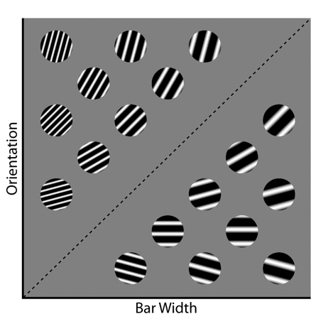

Figure 1. Some stimuli that might be used in an information-integration category learning experiment.

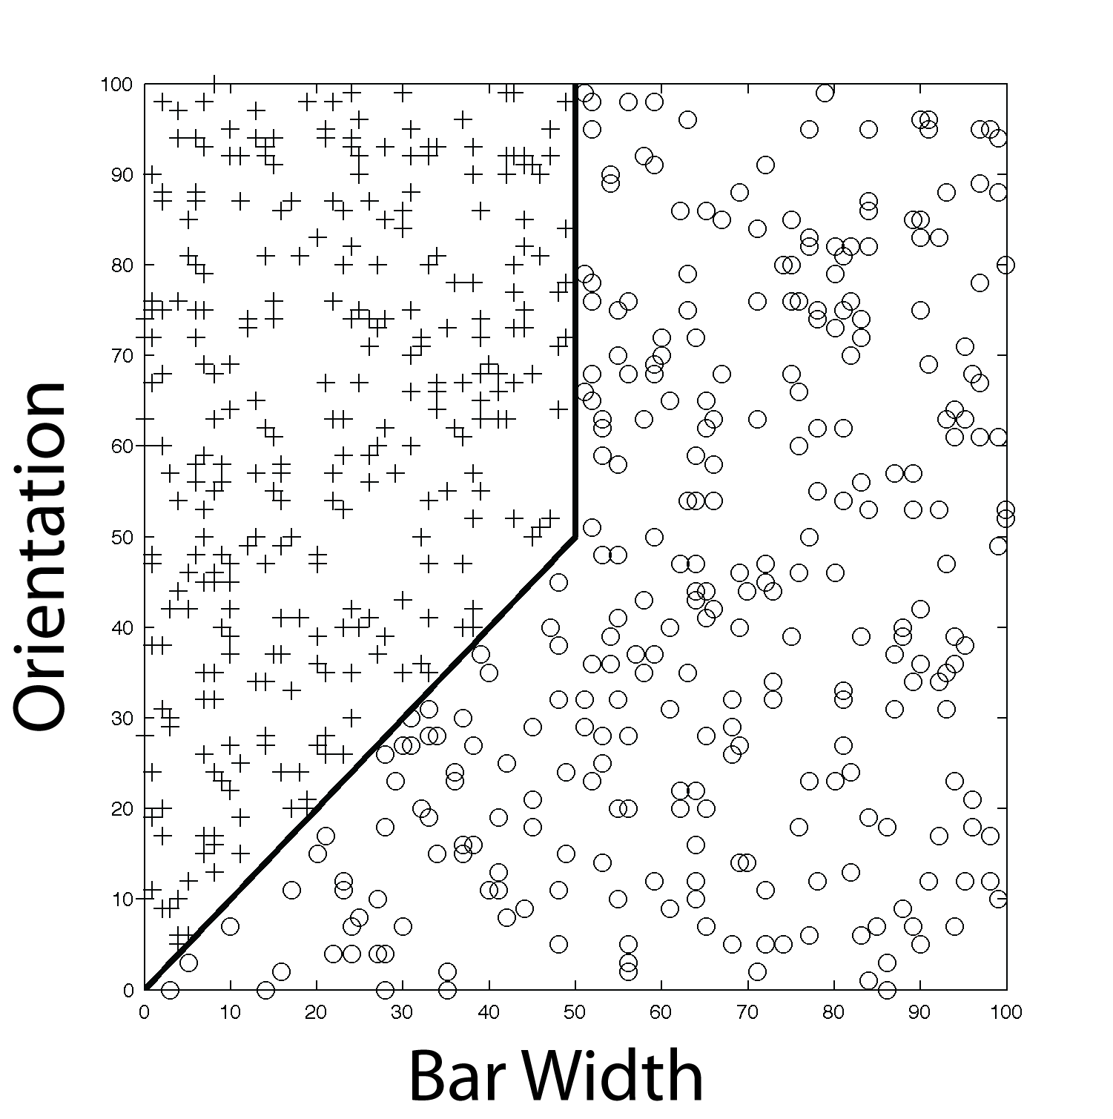

Figure 2. Abstract representation of the hybrid categories used in Experiments 1 and 2. Each plus denotes the bar width and orientation of an exemplar of Category A and each circle denotes the bar width and orientation of an exemplar of Category B. All stimuli were circular sine-wave gratings of the type shown in Figure 1.

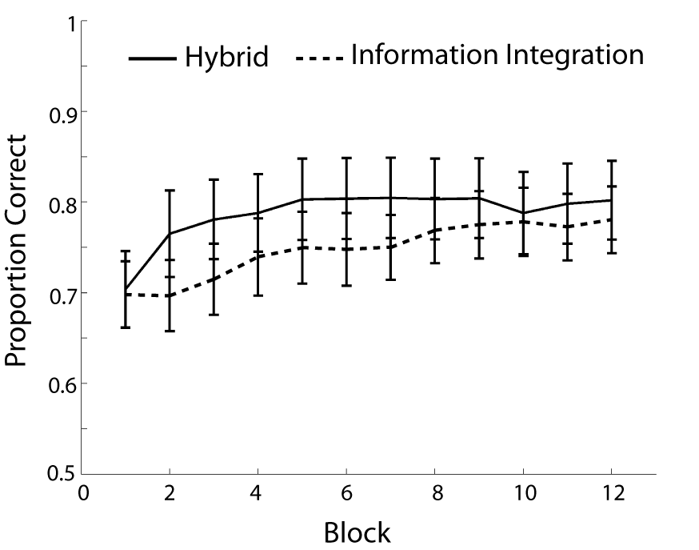

Figure 3. Mean accuracy for each 100-trial block in Experiment 1.

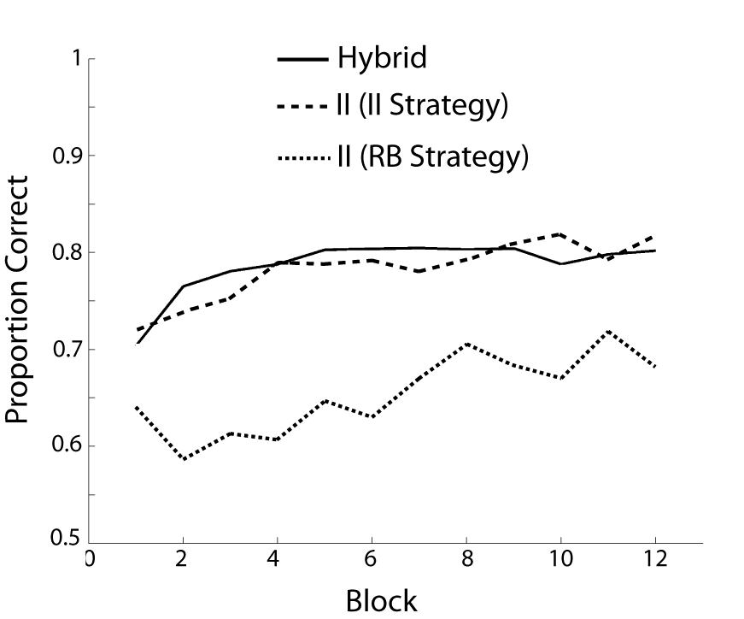

Figure 4. Experiment 1 accuracy where Information-Integration Condition participants are separated by the strategy that best described their responses (II = Information Integration, RB = Rule Based).

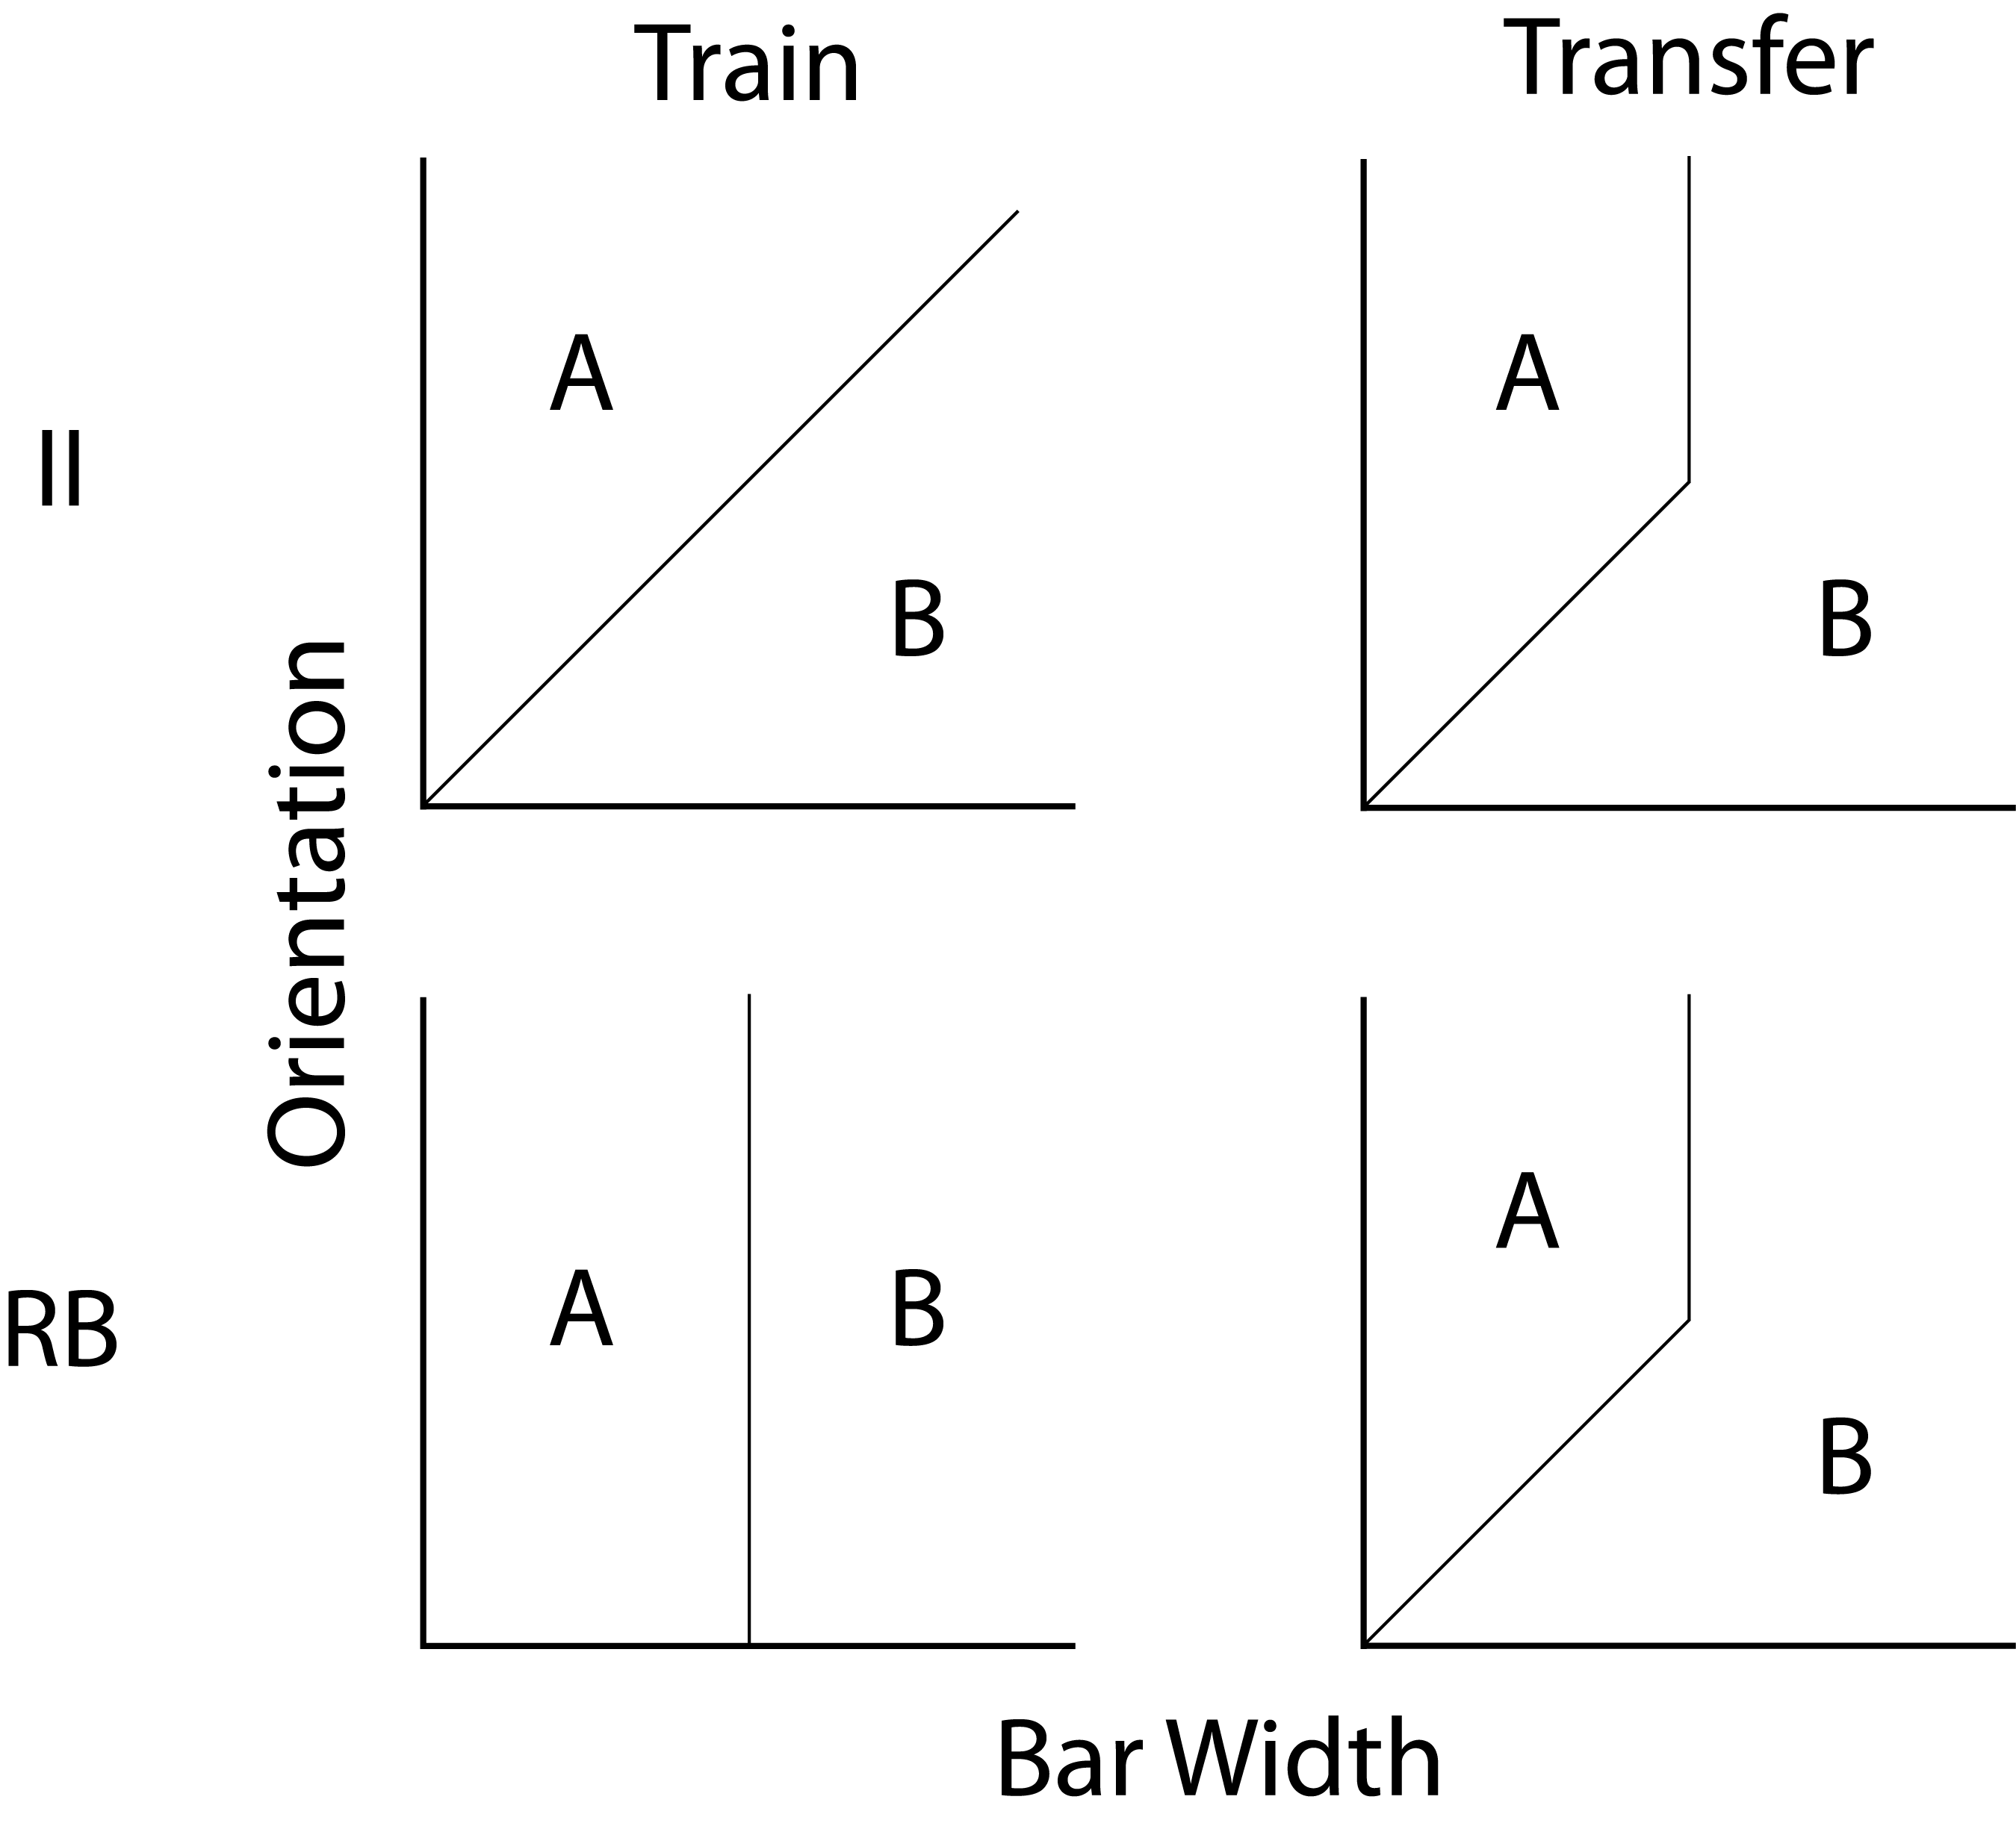

Figure 5. Optimal category boundaries used in the training and transfer conditions of Experiment 2 (II = Information-Integration Training Condition, RB = Rule-Based Training Condition).

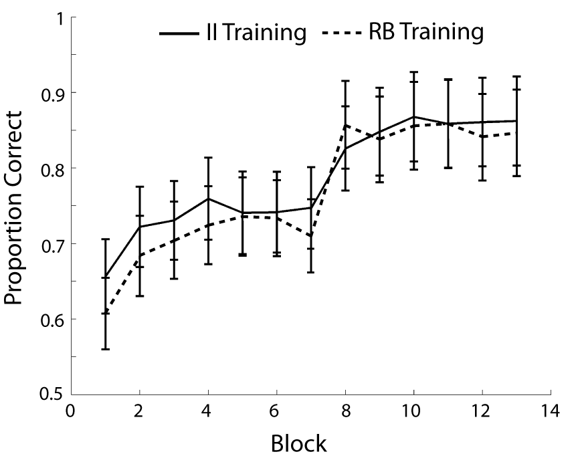

Training
Transfer

Figure 6. Mean accuracy for each 100-trial block during training and transfer in both conditions of Experiment 2 (II Training = Information-Integration Training Condition, RB Training = Rule-Based Training Condition).

